**Blind estimation of acoustic transfer functions with application to signal dereverberation**

You-Siang Chen, Anchi Yuan, and Mingsian R. Baia)

1. *Department of Power Mechanical Engineering, National Tsing Hua University, No.* 101*, Section* 2*, Kuang-Fu Road, Hsinchu, Taiwan* 30013

*Suggested running title: Blind system identification*

1. Corresponding author: Mingsian R. Bai, Email: [msbai63@gmail.com](mailto:msbai63@gmail.com)

**ABSTRACT**

**PACS number**:

**I. INTRODUCTION**

**II. BASELINE APPROACH**

**III. CTF SIGNAL MODEL**

與ISPPACS or ICASSP差不多即可

1. **PROPOSED METHOD**

這裡先講一下整個方法的流程

1. **TDOA-based Source Localization**

提到因為沒有聲源信號所以要先求得聲源位置來讓接下來pre-processing可以順利進行

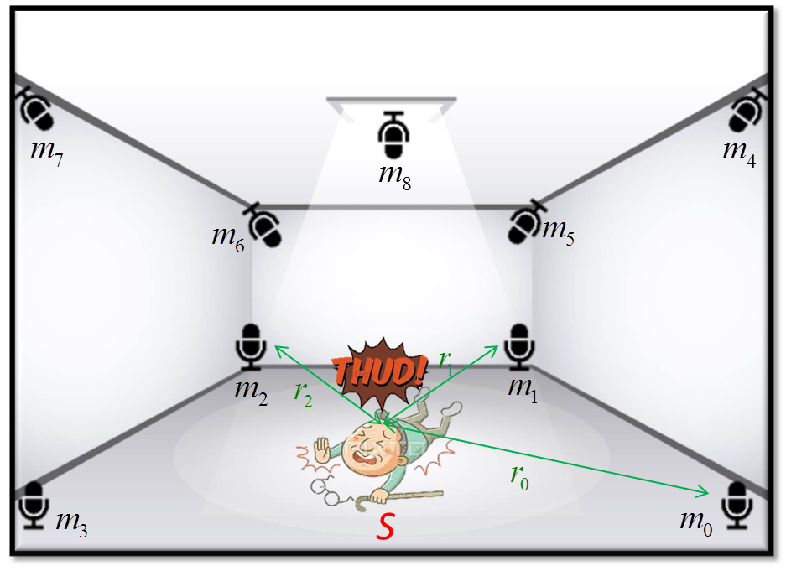

FIG. 1 Relative positions of microphones and the sound source in TDOA-based source localization algorithm.

1. **Pre-processing**

簡短的提到WPE以及DAS即可

1. **Wiener Filter Approach**
2. **RLS Approach**

這個方法可保留可不保留

1. **Kalman Filter Approach**
2. **ATF Reconstruction**

老師上次不喜歡寫得太簡略，所以STFT那些可能要寫很詳細

1. **Parameters Optimization**

這個小結也是視情況可以省略不寫

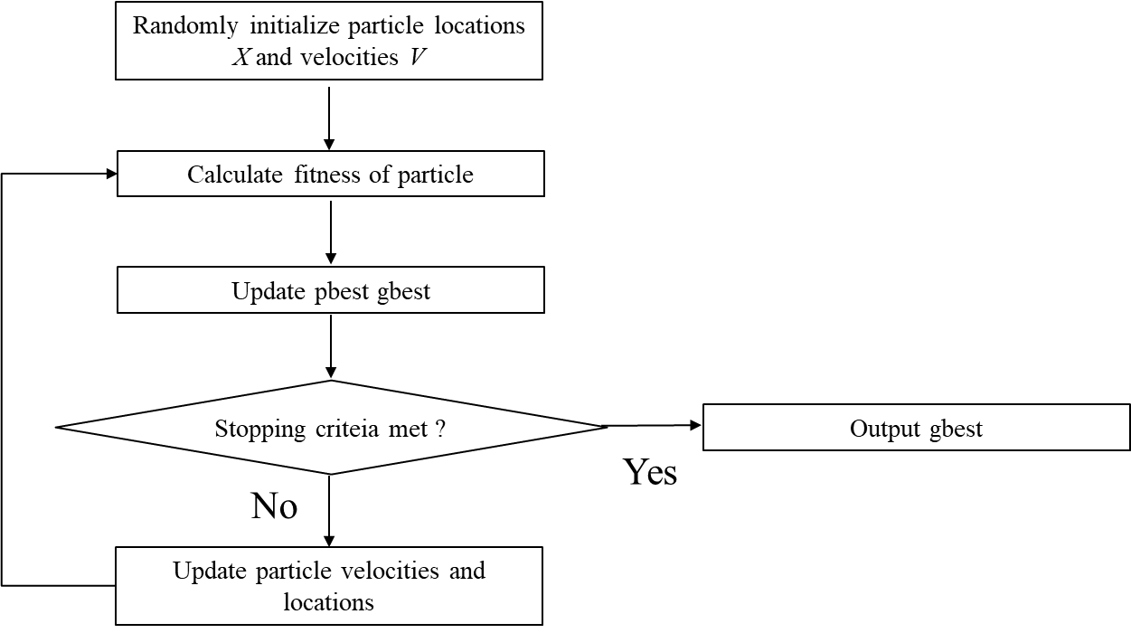

FIG. 2 Block diagram of PSO.

1. **Summary of Proposed Method**

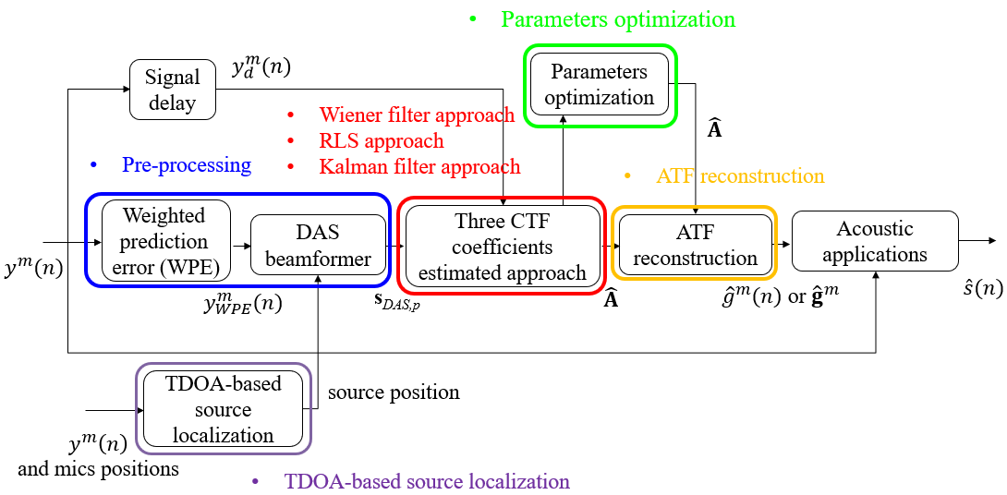

FIG. 3 Flow chart of the proposed method.

其他口委在口試時蠻喜歡這張圖的，也可以改成proposed method這章節一開頭就放

1. ***SIMULATION*S**
2. **Settings and Parameters**

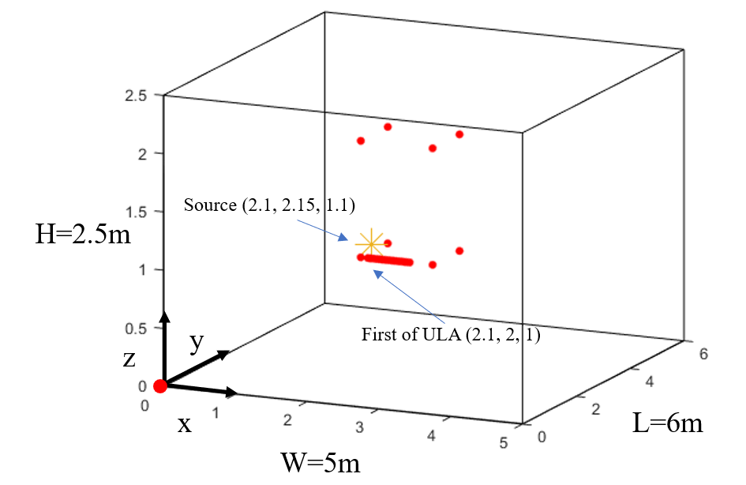

FIG. 4 Configurations of the room for fixed source location.

因為其實用了三種房間設置，所以感覺可以只放一張圖，然後說哪裡改變了

1. **Results and Discussions**

這小節可以再細分成以下四種

1. Fixed Source Location Cases (FIG. 5 FIG. 6 FIG. 7)
2. Fixed Source Location with Parameters Optimization (純放數據即可)
3. Application of Estimated ATFs and RIRs (FIG. 8)
4. Moving Source Location Cases (FIG. 9)



(a)



(b)



(c)



(d)

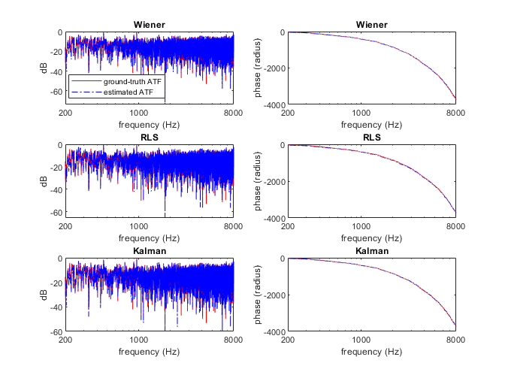

(e)



(f)

FIG. 5 Magnitude and phase of the estimated ATF and amplitude of the estimated RIR of all algorithms with several chosen *T*60. (a) ATF with *T*60= 0.01s. (b) RIR with *T*60= 0.01s. (c) ATF with *T*60= 0.6s. (d) RIR with *T*60= 0.6s. (e) ATF with *T*60= 1.6s. (f) RIR with *T*60= 1.6s.



FIG. 6 The eigenvalues of the microphone covariance matrix in MCLMS.

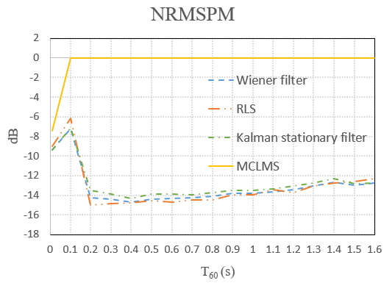

FIG. 7 NRMSPM of the estimated RIRs for all algorithms at different *T*60.

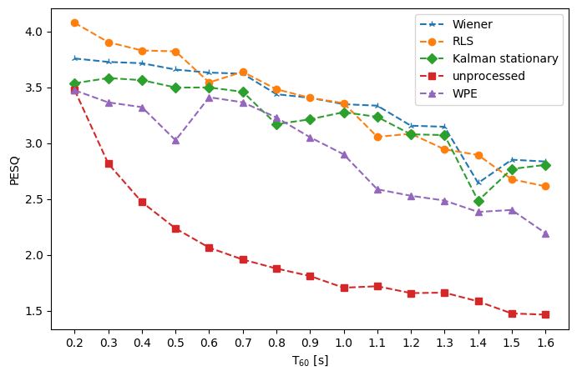

(a)

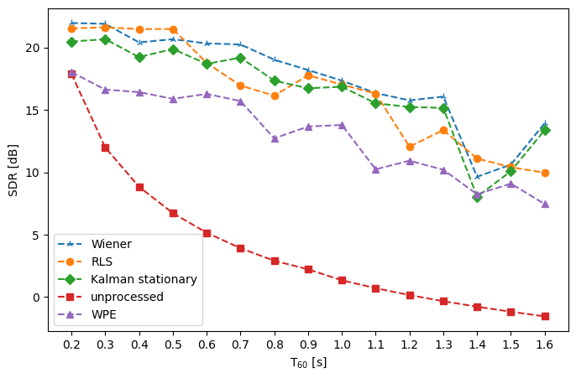

(b)

FIG. 8 (a) PESQ and (b) SDR of MINT de-reverberated signal using RIR estimated by all algorithms, WPE signal and unprocessed signal.



(a)



(b)



(c)



(d)

FIG. 9 Magnitude and phase of the estimated ATF and amplitude of the estimated RIR when the sound source is displaced by 0.3m. (a) ATF of Stationary Kalman filter. (b) RIR of stationary Kalman filter. (c) ATF of Non-stationary Kalman filter. (d) RIR of Non-stationary Kalman filter.

1. ***EXPERIMENT*S**
2. **Settings and Parameters**

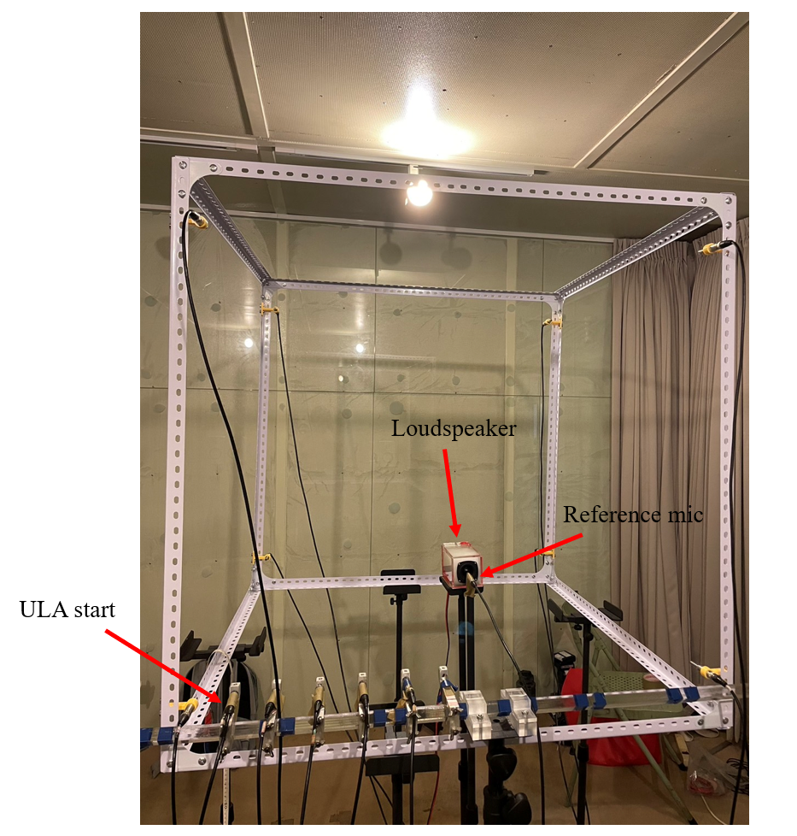

FIG. 10 Picture of the experimental setup.

1. **Results and Discussions**



(a)



(b)



(c)



(d)

FIG. 11 Magnitude and phase of the estimated ATF and amplitude of the estimated RIR obtained from the experiment. (a) ATF of stationary Kalman filter. (b) RIR of stationary Kalman filter. (c) ATF of MCLMS. (d) RIR of MCLMS.

1. ***CONCLUSION*S**

老師很注重為甚麼MCLMS(baseline method)為甚麼沒辦法做長的RIR所以一定要寫進去

**ACKNOWLEDGMENTS**

**REFERENCES**

1. J. Benesty, T. Gänsler, D. R. Morgan, M. M. Sondhi, and S. L. Gay, “Advances in Network and Acoustic Echo Cancellation,” New York: Springer., 2001.
2. 第一條是示範例而已